|  |  |
| --- | --- |
|  | Hocus Pocus Cat Hotel  2 Dalhams, Poole Street, Cavendish, CO10 8BE  Phone: 07922 665131  Email: [joanne@hocuspocuscathotel.com](mailto:joanne@hocuspocuscathotel.com) |

**VIEWING FORM**

|  |  |
| --- | --- |
| Date and Time of Viewing: | *Saturdays between 10am and 12pm only.* |

|  |  |  |  |  |
| --- | --- | --- | --- | --- |
| Full Name: |  | | | |
| Full Address:  *(Inc, Postcode)* |  | | | |
| Telephone no. |  | | | |
| Email Address: |  | | | |
| Cat(s) Name: |  | | | |
| Possible dates required for boarding: | From: |  | To: |  |

*CLOSED SUNDAYS & BANK HOLIDAYS

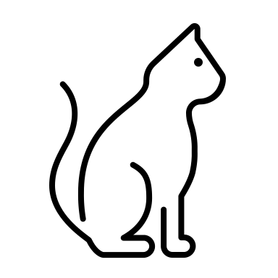

**When viewing the cattery, we politely ask that you refrain from touching the cats who are boarding.**