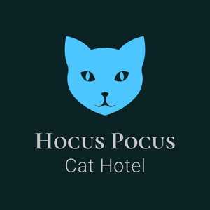 | Hocus Pocus Cat Hotel  2 Dalhams, Poole Street, Cavendish, CO10 8BE  Phone: 07922 665131  Email: joanne@hocuspocuscathotel.com

VIEWING FORM

Date and Time of Viewing: | Saturdays between 10am and 12pm only.

Full Name:
Full Address:
(Inc, Postcode)

Cat(s) Name:
Possible dates required for boarding: | From: |  | To:
*CLOSED SUNDAYS & BANK HOLIDAYS

